Faults generally encountered in Induction Motors
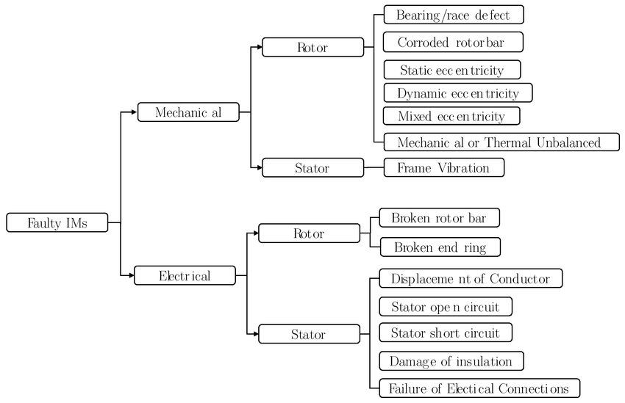
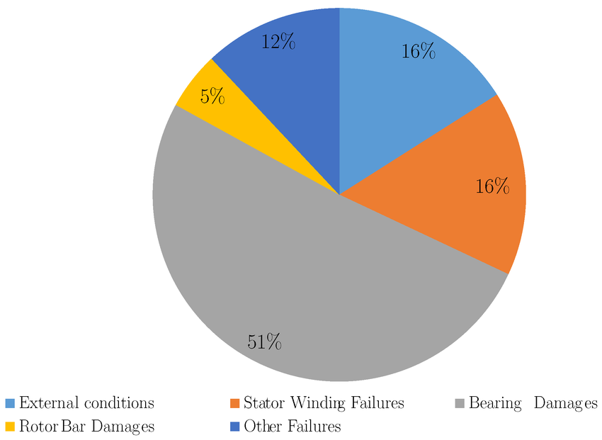

Source:- https://www.researchgate.net/figure/of-different-types-of-faults-in-induction-machines-12_fig1_353335943
- Overview: The Framework You Need First — The P-F Curve
- Before cataloging faults, it's worth anchoring everything in one concept because it directly answers your "detect before things go bad" framing: the P-F Curve.
- It maps an asset's health from P (the earliest Potential failure point — first detectable sign something is wrong) to F (Functional failure — the machine actually stops working). The gap between P and F is your window to act. Two things matter enormously for your project:
- Different sensing techniques detect the P point at different times. Some catch problems months out; others only catch them once damage is already substantial. This directly determines how "predictive" your three sensors actually are, per fault type.
- You must monitor more frequently than the P-F interval, or you'll miss the window entirely — this is a systems-design point relevant to how often your firmware should sample, not just what it senses.
- Fault Statistics — Where to Focus Your Effort
- Multiple large-scale surveys (IEEE Std 493 "Gold Book," EPRI, ABB) converge on a consistent ranking, so this isn't your product decision to make from scratch — it's already established which faults matter most:
- Fault category | - Share of failures (IEEE/EPRI/ABB range)
- Bearing faults | - 41–51% (dominant category across all three studies)
- Stator winding faults | - 26–36%
- Rotor faults (broken bars, etc.) | - 8–9%
- Other (external, misc.) | - 12–22%
- This validates your project's existing thesis focus (bearing + winding faults) — together these two categories account for roughly 70–85% of real induction motor failures. You're targeting the right problems.
- Fault-by-Fault: Mechanism, Progression, and Which Sensor Catches It When
- 1. Bearing Faults (dominant category — your vibration sensor's job)
- What physically happens: Rolling-element bearings degrade through fatigue. Microscopic subsurface cracking begins first, invisible even under a microscope, eventually surfacing as pitting/spalling on the race or rolling elements, which then generates increasingly severe vibration and eventually noise, heat, and mechanical looseness.
- Four measurable degradation stages, and what detects each:
- Stage | - What's happening | - Detectable by | - Timing before failure
- Stage 1 | - Insufficient lubrication, earliest subsurface stress | - Ultrasound (30–50 kHz) — outside your IIS3DWB's range | - Earliest possible signal
- Stage 2 | - Bearing fault begins, micro-cracks reach surface, bearing "rings" at natural frequencies | - Vibration (high-frequency energy rise) | - Weeks to months out
- Stage 3 | - Fault frequencies (BPFO/BPFI/BSF) clearly visible in FFT spectrum | - Vibration FFT — this is your sensor's sweet spot | - This is cited as the optimal intervention point — clear signature, still time to plan repair
- Stage 4 | - Broadband vibration increase, audible noise, heat generation | - Vibration (severe), temperature (now finally relevant), audible | - Failure imminent, days at most
- Key honest finding for your documentation: temperature is a late-stage indicator for bearing faults specifically — by the time a bearing is measurably hotter, it's often already at Stage 4. Vibration is doing the real early-warning work here; temperature is more of a confirmation/severity signal for this particular fault type, not primary detection. Worth stating explicitly rather than implying all three sensors contribute equally to every fault.
- 2. Stator Winding Faults (second largest category — your current sensor's job)
- What physically happens: Insulation breakdown between winding turns, starting as a localized inter-turn short circuit within a single phase, which — if undetected — cascades into phase-to-phase or phase-to-ground faults and eventually catastrophic winding failure. Root causes are typically thermal aging, voltage stress, or contamination degrading the insulation over time.
- Detection: This is squarely MCSA's job — an inter-turn short circuit creates asymmetry in the stator's magnetic field, which shows up as specific harmonic sidebands in the current spectrum before the fault has progressed far enough to trip protection or cause visible damage. This is a genuinely predictive signal, not just a "motor is already dying" signal — a single shorted turn is detectable well before it cascades into a multi-phase fault.
- Temperature's role here: actually more useful for this fault than for bearings — insulation degradation is often thermally driven and self-accelerating (a developing short generates localized heat, which further degrades insulation, which worsens the short). Your PT100/SHT31 data can provide corroborating evidence and even leading indication if you're tracking gradual thermal trends over time, not just instantaneous readings.
- 3. Rotor Faults — Broken Bars (smaller category, but your project already covers it)
- What physically happens: Cracks or breaks in the rotor's conducting bars or end-rings, usually from thermal cycling stress during frequent starts/stops (a detail relevant to your fridge/AC compressor testbeds, which cycle on/off constantly — actually a realistic stress pattern, not just a convenient dev proxy).
- Detection: Classic MCSA sideband analysis around the fundamental frequency, driven by slip — this is the technique your whole current-sensing architecture is built around. Progresses more gradually than you'd think; a single broken bar is often detectable current-signature-wise well before it causes noticeable performance loss.
- Synthesis: What Each Sensor Is Actually Good At (Be Honest About This in Your Docs)
- Sensor | - Best at | - Weaker at
- Vibration (IIS3DWB) | - Bearing faults — genuinely early-warning, weeks-to-months lead time at Stage 2–3 | - Doesn't directly see electrical/winding faults
- Current (CT + MCSA) | - Stator winding faults, broken rotor bars — early, before cascading | - Doesn't see purely mechanical bearing wear until it's severe enough to show up as load irregularity
- Temperature (PT100/SHT31) | - Confirming/corroborating signal, especially useful for thermally-driven insulation degradation trends | - Generally a lagging indicator for bearing faults specifically — by the time it's hot, damage is advanced
- This is actually a strong finding for your documentation: your three sensors aren't three redundant views of "motor health" — they're three largely non-overlapping fault-detection channels, each primarily responsible for a different failure category, with temperature acting more as a cross-validation/trend signal than a primary detector for most faults. That's a mature systems-design insight worth stating explicitly rather than assuming multi-sensor fusion is valuable in some vague, unspecified way.
- Common Mistakes to Avoid
- Treating this as "three sensors, more data is better" without articulating which sensor catches which fault at which stage — that's the difference between a real multi-modal fault-detection architecture and just throwing sensors at a motor and hoping ML sorts it out.
- Resume/Portfolio Impact
- A fault-taxonomy table like the one above — grounded in IEEE/EPRI statistics, mapped explicitly to sensor capability and detection timing — is exactly the kind of artifact that turns your Sensor Selection Report into a genuine engineering document rather than a shopping list justification. It directly answers "why these three sensors, and what does each one actually contribute" in a way that survives scrutiny.
- Want to go deeper into the specific FFT sideband math for either bearing fault frequencies or MCSA current sidebands next, so you have the actual formulas ready for your firmware/analysis pipeline?

